

Lab 1 – Group 5 – Modular Servo

MohammadParsa Dini 400101204 – Reza Nazarie – Reza Ghane’

1. Calibration:
2. Record the output disk angle, the shaft angle and the encoder output for three measurements in Table 1.

First, we set the controller signal to zero and monitored the encoder's angle. Initially, it started at one angle and ended at another, indicating that it eventually stopped. During this process, it maintained a relatively constant angular velocity.

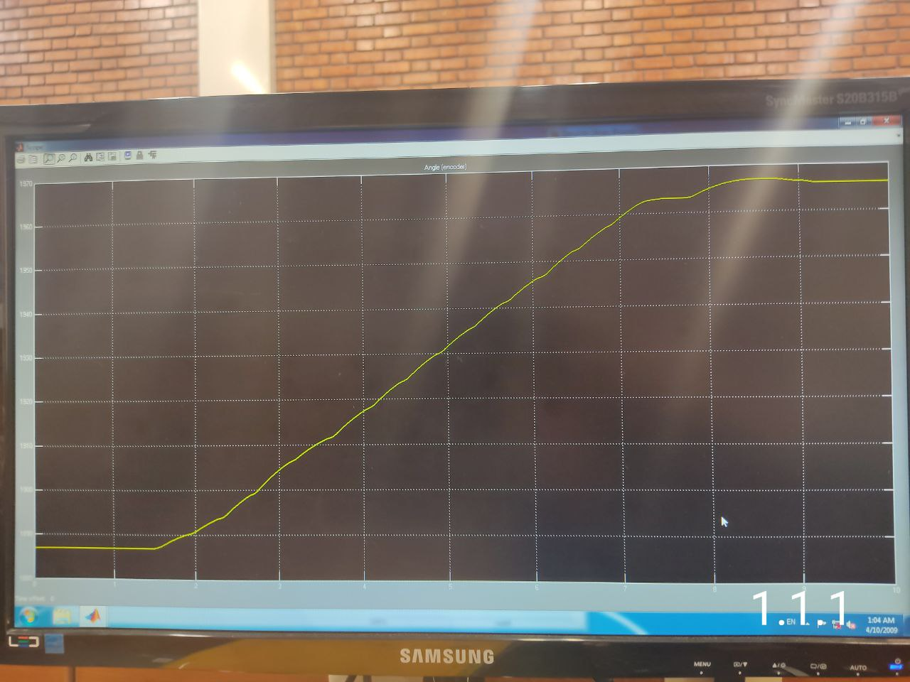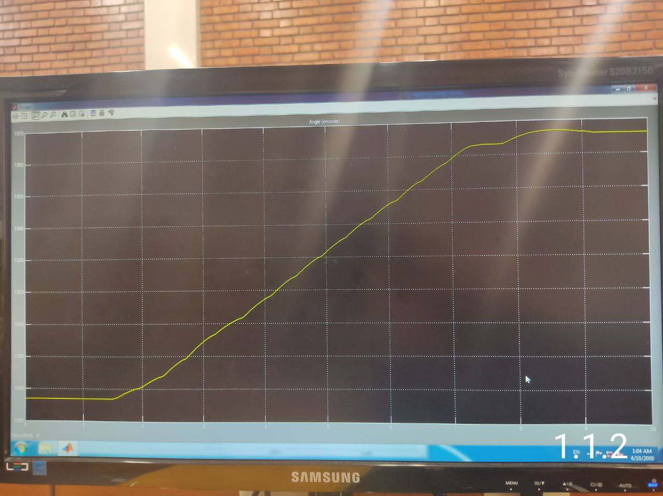

Since $θ_{shaft}=θ_{disk}×(Gear Ratio=25)$ and

$\left(Encoder Counts\right)=\frac{(Encoder Resolution \frac{counts}{rev})}{360},$ we get:

|  |  |  |
| --- | --- | --- |
| Output disk angle in degrees ($θ_{disk}$) | Shaft angle in degrees ($θ_{shaft}$) | Encoder output in counts |
| $$90$$ | $$2250$$ | $$39$$ |
| $$135$$ | $$3375$$ | $$60$$ |
| $$180$$ | $$4500$$ | $$80$$ |

1. Record the encoder resolution.
$$ER=360×\frac{1}{3}\left(\frac{39}{2250}+\frac{60}{3375}+\frac{80}{4500}\right)=6.35≈6 or 7$$

2. Record the tachogenerator calibration data in Table 2.

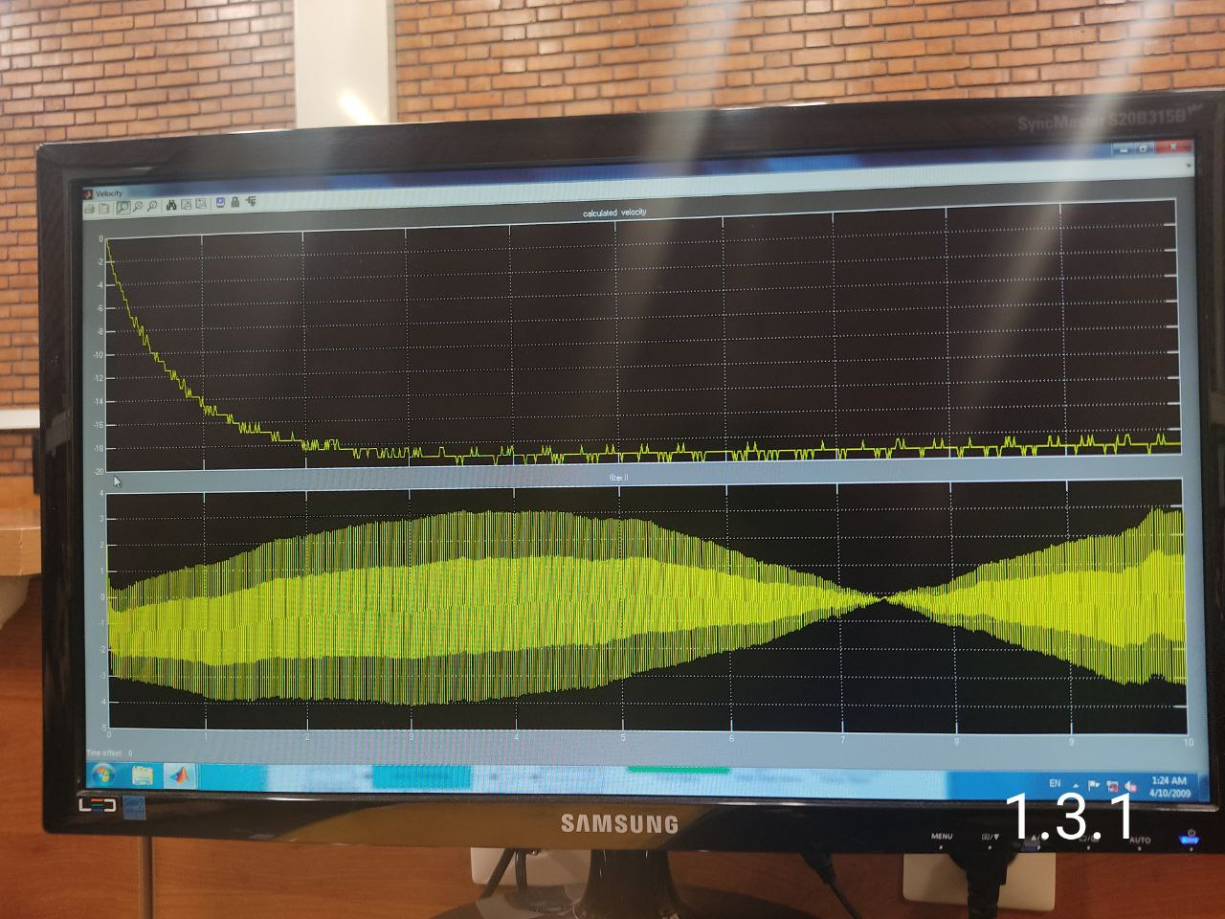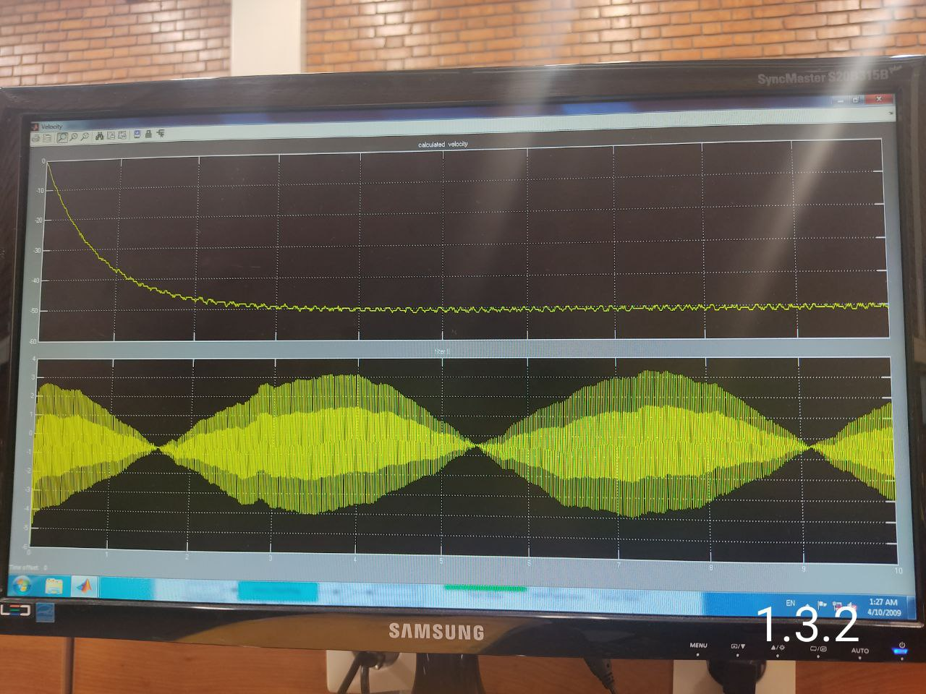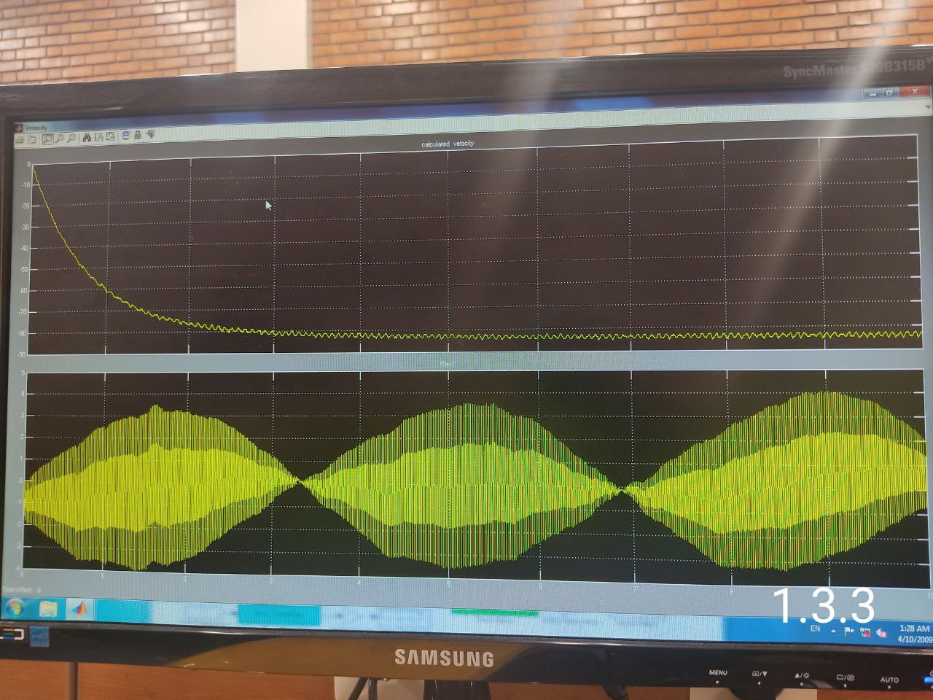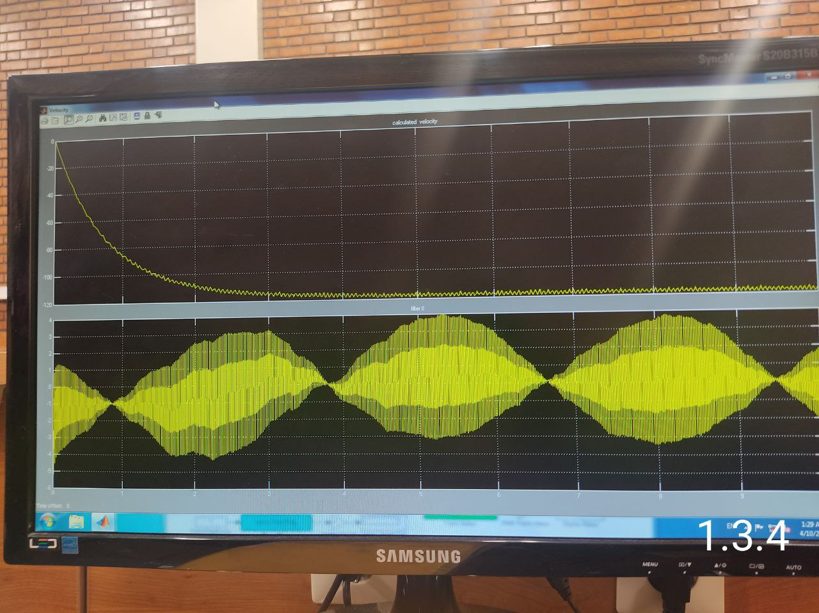

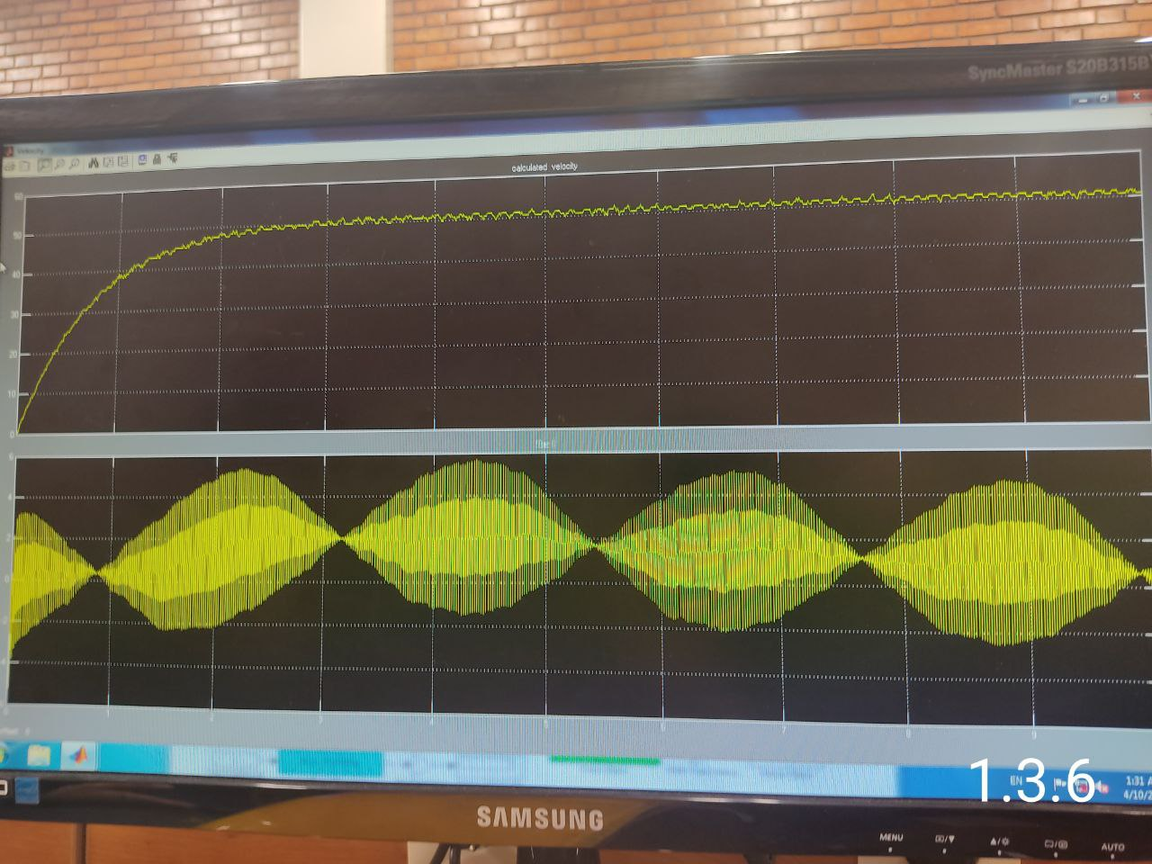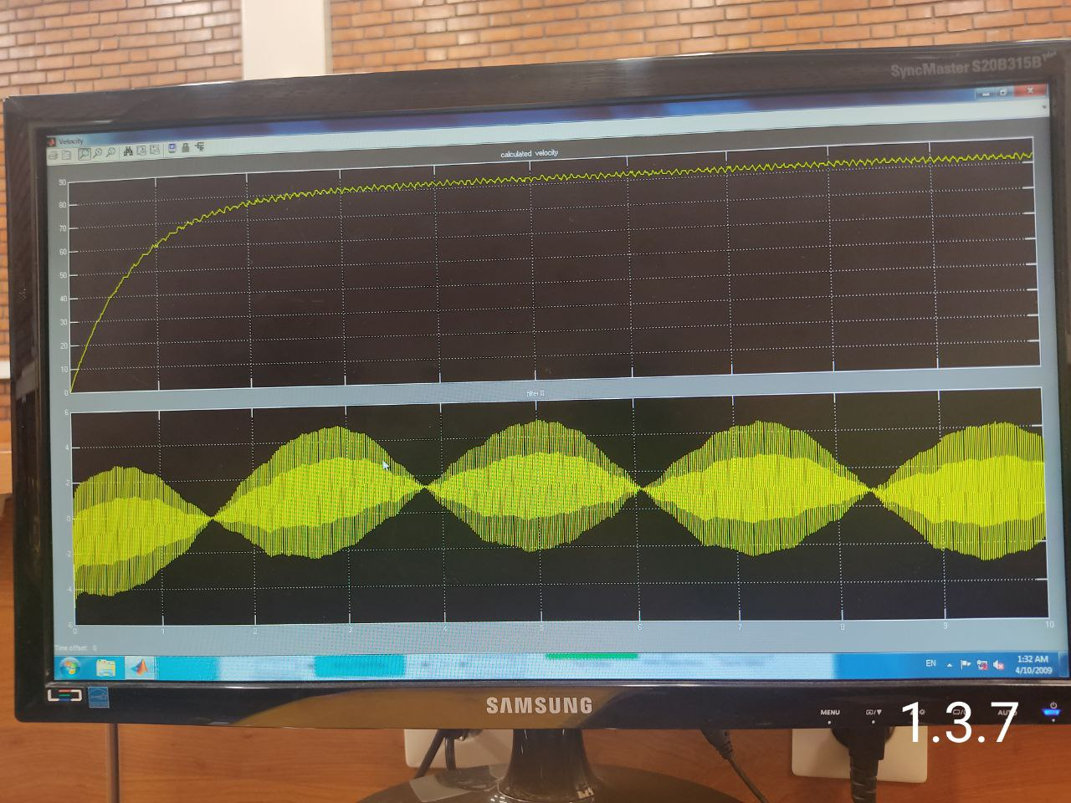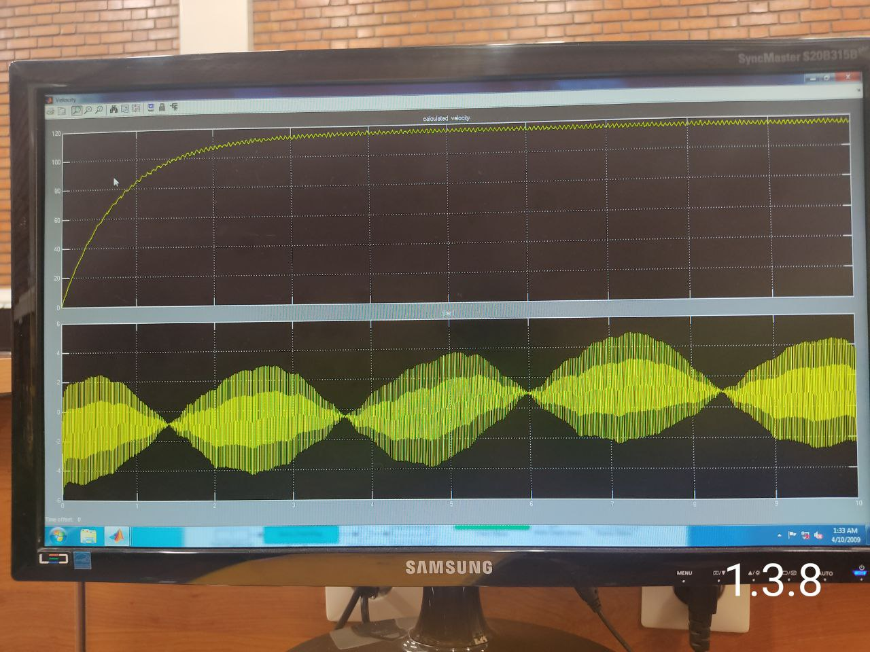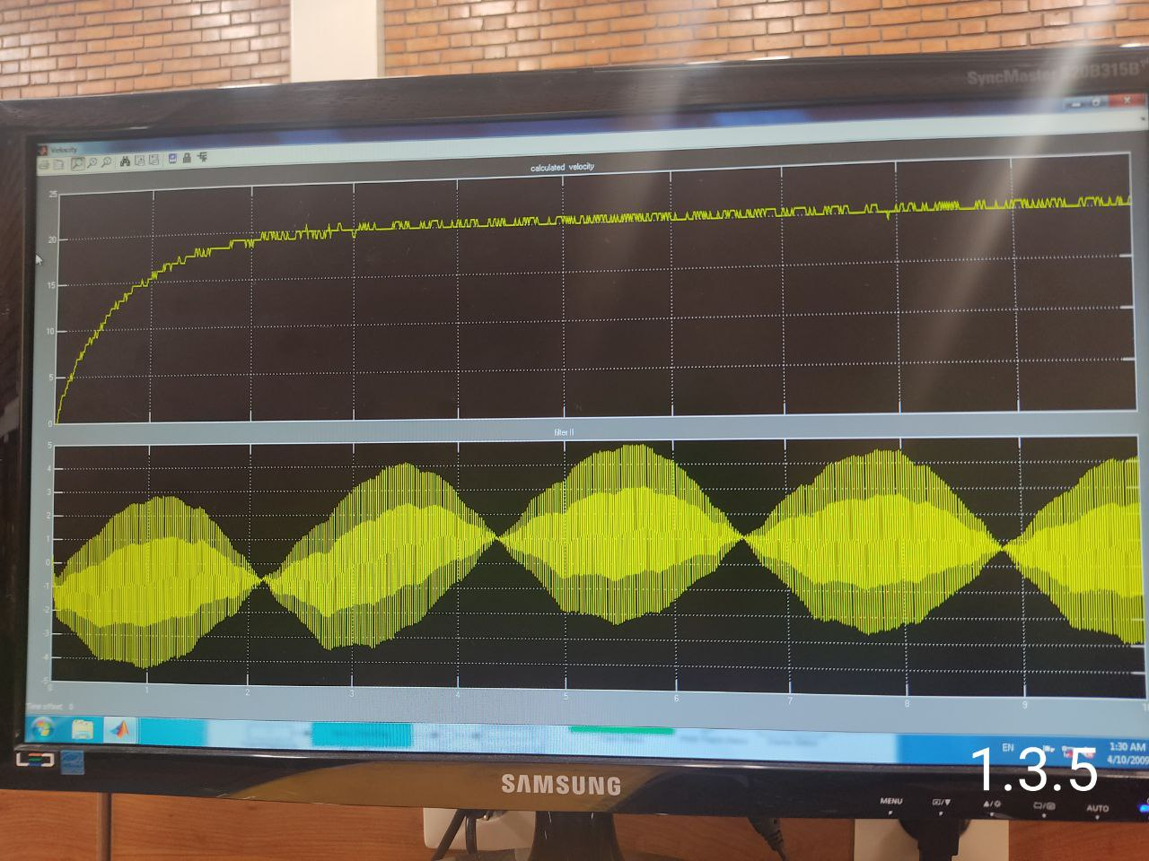

|  |  |  |  |
| --- | --- | --- | --- |
| Input Signal | Tacho voltage ($V$) | Measured velocity $$\frac{rev}{min}$$ | Measured velocity $$\frac{rad}{s}$$ |
| $$+0.2 u(t)$$ | 2.9 | 200.53 | 21 |
| $$+0.4 u(t)$$ | 3.3 | 496.56 | 52 |
| $$+0.6 u(t)$$ | 3.4 | 792.59 | 83 |
| $$+0.8 u(t)$$ | 4.1 | 1117.26 | 117 |
| $$-0.2 u(t)$$ | -3.0 | -181.43 | -19 |
| $$-0.4 u(t)$$ | -3.3 | -487.01 | -51 |
| $$-0.6 u(t)$$ | -4.0 | -802.14 | -84 |
| $$-0.8 u(t)$$ | -4.2 | -1126.81 | -118 |

1. Plot the tachogenerator voltage as a function of the measured velocity ($rad/s$).

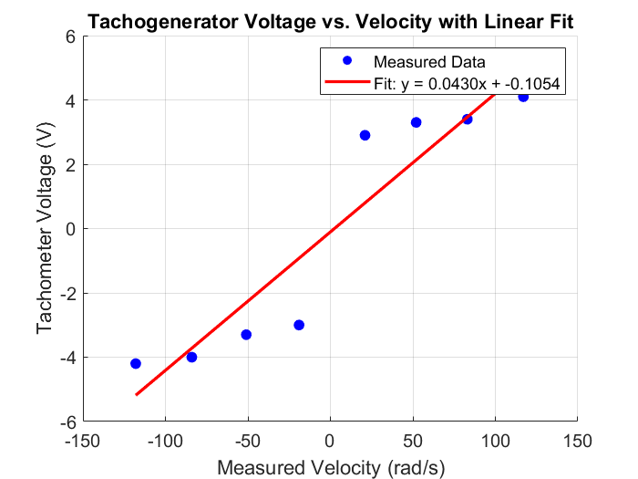

1. Determine the tachogenerator calibration gain $K_{T}$ (back-emf constant) in ($V/(\frac{rad}{s})$) using linear approximation:

% Define the data

velocity_rad_s = [21, 52, 83, 117, -19, -51, -84, -118]; % Measured velocity (rad/s)

tacho_voltage = [2.9, 3.3, 3.4, 4.1, -3.0, -3.3, -4.0, -4.2]; % Tacho voltage (V)

% Fit a linear model (y = ax + b) using polyfit (degree 1)

p = polyfit(velocity_rad_s, tacho_voltage, 1); % p(1) = a (slope), p(2) = b (intercept)

% Extract a and b

a = p(1); % Slope (KT in V/(rad/s))

b = p(2); % Intercept (V)

% Display the results

fprintf('Linear fit: Tacho Voltage = %.4f * Velocity + %.4f\n', a, b);

fprintf('Tachogenerator calibration gain (KT) = %.4f V/(rad/s)\n', a);

% Generate points for the fitted line

x_fit = linspace(min(velocity_rad_s), max(velocity_rad_s), 100); % Range of velocities

y_fit = a * x_fit + b; % Fitted tacho voltage

% Plot the results

figure;

scatter(velocity_rad_s, tacho_voltage, 50, 'b', 'filled', 'DisplayName', 'Measured Data'); % Data points

hold on;

plot(x_fit, y_fit, 'r-', 'LineWidth', 2, 'DisplayName', sprintf('Fit: y = %.4fx + %.4f', a, b)); % Fitted line

hold off;

% Add labels and title

xlabel('Measured Velocity (rad/s)');

ylabel('Tachometer Voltage (V)');

title('Tachogenerator Voltage vs. Velocity with Linear Fit');

legend('show');

grid on;

% Adjust plot appearance

set(gca, 'FontSize', 12);

we got::

$$y=0.43x-0.1054$$

1. Comment on whether or not the angular velocities are measured correctly

Well, since there is always noise propagated to the measurements, we can always have uncertainty and error, furthermore, some environmental factors may have effects on measurements. While we were taking the outputs, we observed the voltage having complex conjugate poles which resulted in damped sinusoidal oscillation which made it harder for us to measure the voltage.

1. Servo Characteristics
2. Record the input signal sequence and steady-state angular velocities in Table 3.

|  |  |  |  |  |  |  |  |  |  |  |
| --- | --- | --- | --- | --- | --- | --- | --- | --- | --- | --- |
| Input Signal | $$-1$$ | $$-0.6$$ | $$-0.4$$ | $$-0.2$$ | $$-0.17$$ | $$-0.14$$ | $$-0.12$$ | $$-0.09$$ | $$-0.05$$ | $$-0.01$$ |
| Angular Velocity | $$-172.7$$ | $$-90.8$$ | $$-48.5$$ | $$-13.6$$ | $$-8.5$$ | $$-3.7$$ | $$-0.7$$ | $$0.012$$ | $$0.012$$ | $$0.012$$ |
| Input Signal | $$0.01$$ | $$0.05$$ | $$0.09$$ | $$0.12$$ | $$0.14$$ | $$0.17$$ | $$0.2$$ | $$0.4$$ | $$0.6$$ | $$1$$ |
| Angular Velocity | $$0.011$$ | $$0.011$$ | $$0.013$$ | $$0.5$$ | $$2.7$$ | $$6.6$$ | $$11.2$$ | $$47.1$$ | $$85.2$$ | $$168.9$$ |

1. Plot and print the steady-state values of angular velocity as a function of the input signal level.

% Data

input_signal = [-1, -0.6, -0.4, -0.2, -0.17, -0.14, -0.12, -0.09, -0.05, -0.01, 0.01, 0.05, 0.09, 0.12, 0.14, 0.17, 0.2, 0.4, 0.6, 1];

angular_velocity = [-172.7, -90.8, -48.5, -13.6, -8.5, -3.7, -0.7, 0.012, 0.012, 0.012, 0.011, 0.011, 0.013, 0.5, 2.7, 6.6, 11.2, 47.1, 85.2, 168.9];

% Plot

figure;

plot(input_signal, angular_velocity, '-o');

xlabel('Input Signal');

ylabel('Angular Velocity');

title('Steady-state Values of Angular Velocity as a Function of Input Signal Level');

grid on;

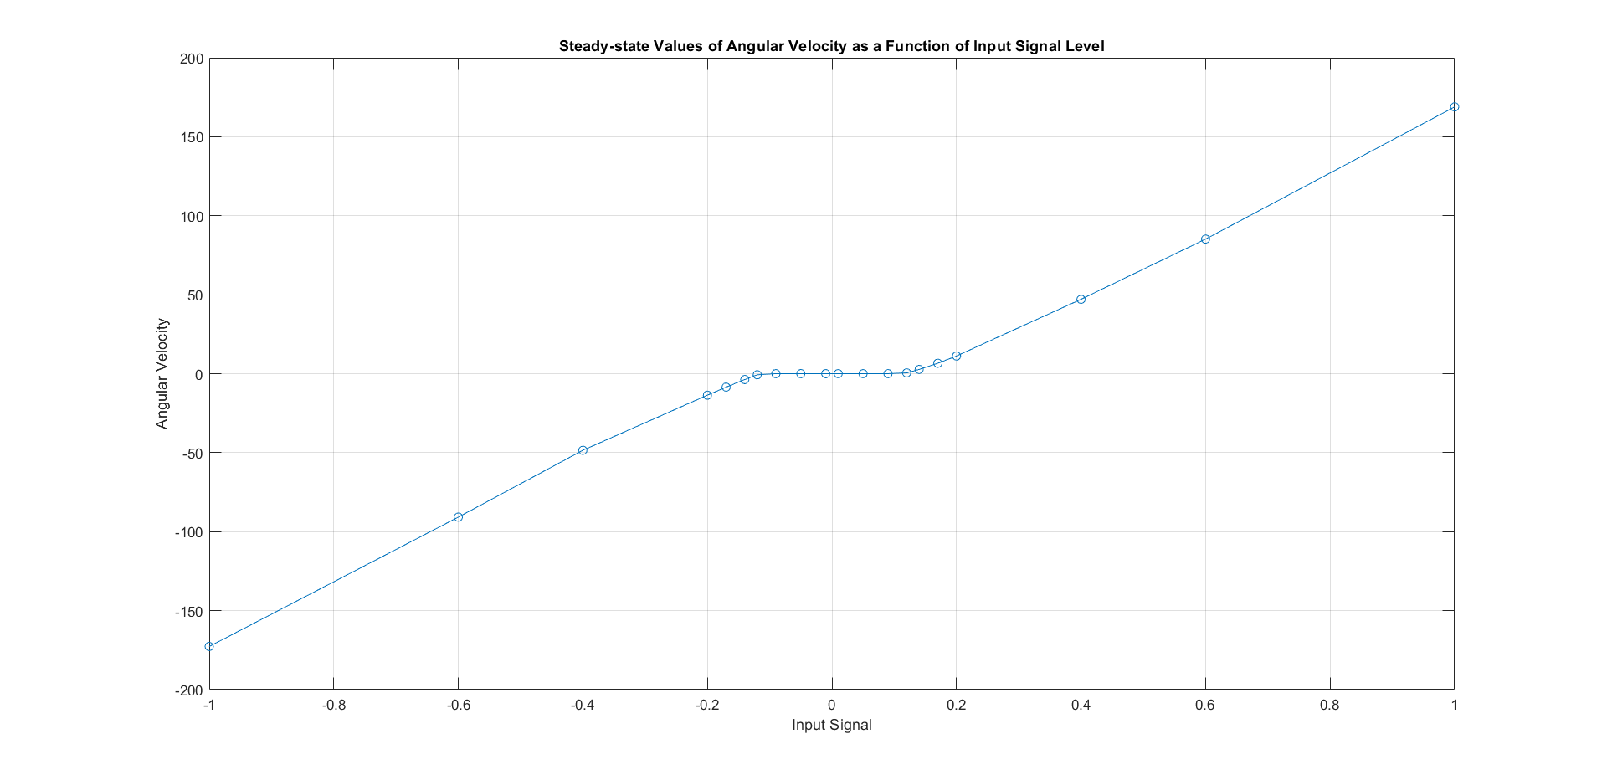

1. Determine the dead-zone and the slope $K_{s}$ using a piece-wise linear approximation.

By using the cursor on the MATLAB figure page, the dead-zone is determined to lie within the interval $[-0.012, 0.012].$ To calculate the $K_{s}$ for each piecewise segment outside the dead-zone, the built-in MATLAB polyfit function is utilized to obtain the average slope for each section.

% Separate the data outside the dead-zone

dead_zone = [-0.012, 0.012];

outside_dead_zone = (input_signal < dead_zone(1)) | (input_signal > dead_zone(2));

% Perform linear fit for negative and positive sections separately

neg_section_idx = input_signal < dead_zone(1);

pos_section_idx = input_signal > dead_zone(2);

% Polyfit for negative section

neg_fit = polyfit(input_signal(neg_section_idx), angular_velocity(neg_section_idx), 1);

Ks_neg = neg_fit(1);

% Polyfit for positive section

pos_fit = polyfit(input_signal(pos_section_idx), angular_velocity(pos_section_idx), 1);

Ks_pos = pos_fit(1);

% Display the results

fprintf('The average slope (Ks) for the negative section: %.4f\n', Ks_neg);

fprintf('The average slope (Ks) for the positive section: %.4f\n', Ks_pos);

By Running this code, we got:

The average slope (Ks) for the negative section: 188.4485

The average slope (Ks) for the positive section: 183.7343

Thus the mean slope is:

$$\overline{K_{s}}=\frac{K_{s}^{+}+K_{s}^{-}}{2}=\frac{188.44+183.73}{2}≈ 186.085\frac{rad/s}{V}$$

1. Based on your findings, explain operational conditions under which the nonlinearities of the servo characteristics should be taken into account in modeling.

Based on our observations, the nonlinearities in servo characteristics must be considered in modeling under specific operational conditions. In particular, the dead-zone interval, identified as $[-0.012, 0.012] V$, introduces significant challenges. Within this range, the system exhibits undesirable and severe oscillations, leading to unpredictable and unwanted outcomes. However, for input signals (voltages) with magnitudes exceeding $12 mV$, the nonlinear effects diminish, and the output is guaranteed to converge to a stable, significant angular velocity.

1. Mathematical Modeling of the Servo System
2. Use the derived electrical and mechanical equations of the servo motor and express the an-gular velocity of the load in terms of the applied motor voltage.

From Electrical equations we got:

$$V_{m}(t)-R_{m}I_{m}(t)-L_{m}\frac{dI_{m}\left(t\right)}{dt}-K_{m}ω(t)=0$$

From Mechanical equations, it implies that:

$$τ=K_{g} I_{m} \& τ=J\dot{ω}+bω → I_{m}=\frac{J\dot{ω}+bω}{K_{g}}$$

Now by replacing $I_{m}$ from above equation in first equation, we will derive:

$$(L_{m}J)ω̈+(R_{m}J+L_{m}b)ω̇+(K_{m}K_{g}+R_{m}b)ω=K_{g}V_{m}(t)$$

1. Explain different modes of the system and their effect on the response of the system.

The equation which we derived in the previous part is a second order one, so It has two poles. As we know in a DC motor, the output velocity won’t oscillate or diverge so the poles must have negative real part which will result in three modes:

* Overdamped: The poles are real with different values. An overdamped system returns to equilibrium but slower than critically damped system which will be mention then.
* Critically Damped: The poles are real and same. A critically damping system returns to equilibrium very fast without overshooting.

* Underdamped: An underdamped system will oscillate through the equilibrium position. In this mode, the poles also have an Imaginary part in addition of negative real part.

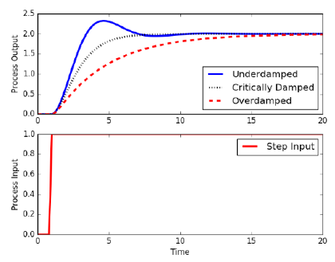

1. Determine the parametric state space model of the system in the form of,

$$ẋ=f(x,u),$$

$$y=Cx$$

where the output y represents the angular position and angular velocity of the servo motor.

𝐴𝑠𝑠𝑢𝑚𝑒 that: $x_{1}=θ$& $x_{2}=ω$& $x_{3}=ω$,

$x_{2}=\dot{x_{1}}$& $x_{3}=\dot{x_{2}}$.

$$\vec{\dot{x} }= \left(\begin{matrix}\dot{x_{1}} \\ \dot{x_{2}} \\ \dot{x_{3}}\end{matrix}\right)=\left(\begin{matrix}0 & 1 & 0 \\ 0 & 0 & 1 \\ 0 & -\frac{K_{m}K_{g}+R_{m}b}{L_{m}J} & -\frac{R_{m}J+L_{m}b}{L_{m}J}\end{matrix}\right)\left(\begin{matrix}x_{1} \\ x_{2} \\ x_{3}\end{matrix}\right)+\left(\begin{matrix}0 \\ 0 \\ \frac{K_{g}}{L_{m}J}\end{matrix}\right)$$

$y={\left(θ , ω\right)}^{T}=$ $[\begin{matrix}1 & 0 & 0 \\ 0 & 1 & 0\end{matrix} ]\left(\begin{matrix}x_{1} \\ x_{2} \\ x_{3}\end{matrix}\right)$

1. Based on the hints in the lab instruction manual, briefly discuss sources of nonlinearities in a more realistic model of the system.

* **Effect of friction:** The relation of friction with velocity is a nonlinear so it also has a nonlinear effect on angular velocity.
* **Effect of dead-zone:** When the angular velocity of the rotor is very slow, so the moment inertia of the body won’t let the motor works properly and has a nonlinear effect.

1. Determine the modified equations of system dynamics by including the velocity dependent friction.

$$T_{total}=T_{e}-T_{f}=K_{g}I_{m}-α_{1}sgn\left(ω\right)-α_{2}e^{-α_{3}\left|ω\right|sgn(ω)}$$

Which suggests:

$$I_{m}=\frac{1}{K_{g}}(J \dot{ω}+bω+α_{1}sgn\left(ω\right)+α_{2}e^{-α_{3}\left|ω\right|sgn\left(ω\right)})$$

Now by replacing in the electrical equation we will derive:

$$V_{m}\left(t\right)-\frac{R_{m}}{K_{g}}\left(J \dot{ω}+bω+α_{1}sgn\left(ω\right)+α_{2}e^{-α_{3}\left|ω\right|sgn\left(ω\right)}\right)-\frac{L_{m}}{K_{g}}\left(J \dot{\dot{ω}}+b\dot{ω}+α_{1}sgn\left(ω\right)-{α_{3}α}_{2}e^{-α_{3}\left|ω\right|sgn\left(ω\right)}\dot{ω}\right)=K_{m}ω\left(t\right)$$

Which suggests:

$$\frac{L_{m}J}{K_{g}}\dot{\dot{ω}}+\frac{R_{m}J+L_{m}b}{K_{g}}\dot{ω}+\frac{R_{m}b+K_{m}K_{g}}{K_{g}}ω+\frac{R_{m}α_{2}-L_{m}α_{2}α_{3}\dot{ω}}{K_{g}}e^{-α_{3}\left|ω\right|sgn\left(ω\right)}=V_{m}\left(t\right)-\frac{R_{m}α_{1}}{K_{g}}sgn\left(ω\right)$$

1. Illustrate a simple block diagram representing the overall nonlinear system dynamics including electrical subsystem, mechanical subsystem, saturation block and nonlinear block $T_{f}(ω)$ defined in the lab instruction manual. Mark the input voltage ($V_{m}$), motor torque (𝜏), disturbance torque $T_{f}(ω)$ and angular velocity (𝜔) on the diagram.

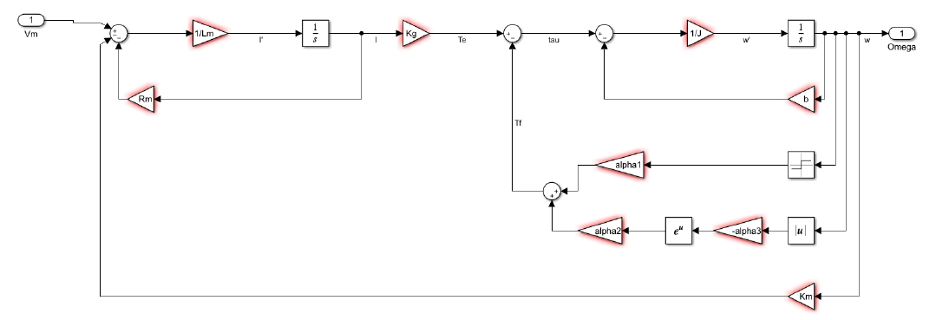

1. Devise and briefly discuss a simple experiment to identify the coefficient c in the nonlinear model.

we model it with a first order differential equation:

$$\dot{ω}=\frac{A}{B}u\left(t\right)-\frac{1}{B}ω\left(t\right)→ Y\left(s\right)=\frac{A}{Bs+1}U\left(s\right), where (\frac{1}{B}=\frac{c}{Ks})$$

$B$ is the time constant of the servo motor so we find it for different bias points and calculate the average time constant. Then we can calculate $c.$

1. Time Domain Identification
2. Assume that (1) the motor inductance $L_{m}$ is negligible, (2) the effects of Coulomb friction is negligible and (3) the dead-zone is excluded from operational condition. Simplify the derived block diagram and write down the resultant first order system.
$$R_{m} J \dot{ω} +\left(K_{m} K_{g}+R_{m} b\right)ω=K_{g} V_{m}$$

$$H\left(s\right)=\frac{ω\left(s\right)}{V_{m}\left(s\right)}=\frac{K_{g}}{\left(K_{m} K_{g}+R_{m} b\right)+s ×R_{m}J}$$

$$H\left(s\right)=\frac{\frac{k_{g}}{\left(K_{m} K_{g}+R_{m} b\right)}}{1+\frac{R_{m}J}{\left(K_{m} K_{g}+R_{m} b\right)}s}=\frac{A}{1+τs}$$

3. Determine the steady-state gain and time constant of the model parametrically.
$$A= \frac{k_{g}}{\left(K_{m} K_{g}+R_{m} b\right)}$$

$$τ= \frac{R_{m}J}{\left(K_{m} K_{g}+R_{m} b\right)}$$

4. For the square wave with zero offset, record the steady-state gain, time constants for the high and low values in Table 4. Are the two time constants the same? Why?

No, clearly since the slope of two sections are different, hence two time constants are not the same.

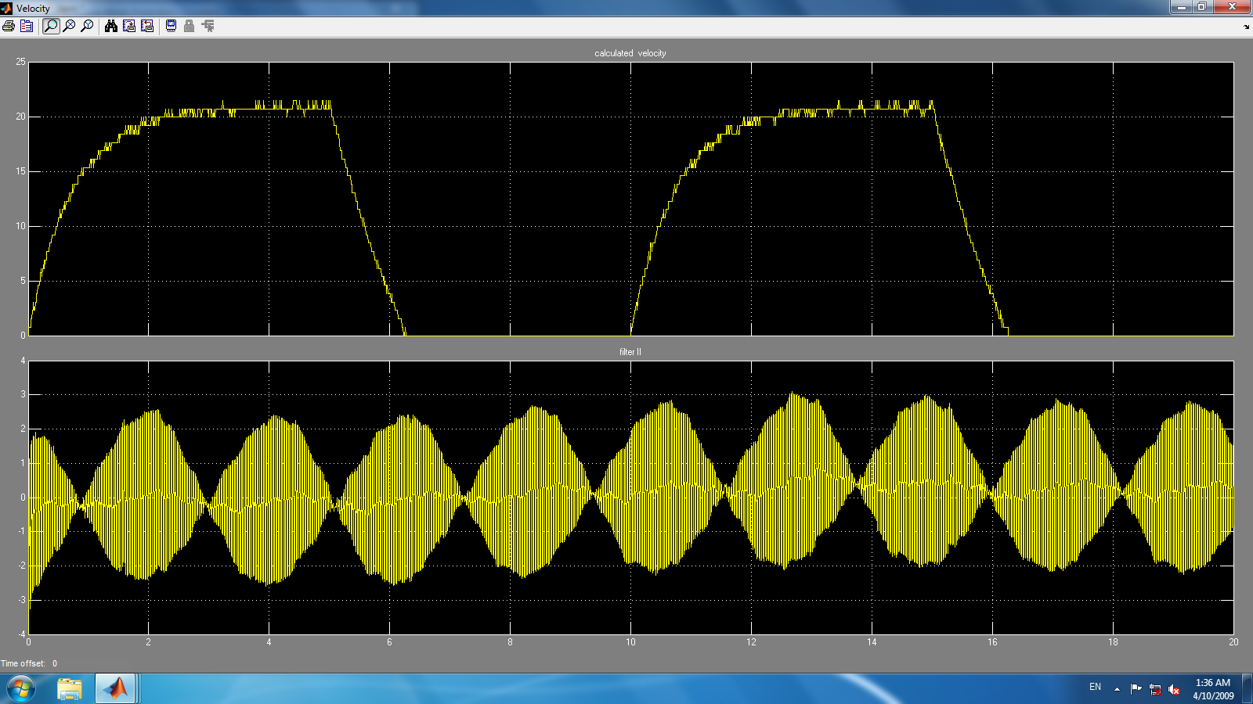

|  |  |  |  |  |
| --- | --- | --- | --- | --- |
| offset | Steady state gain | Time constant for high values $(s)$ | Time constant for low values $(s)$ | Average time constant $(s)$ |
| 0 | 100 | 3.10 | 0.13 | 1.62 |
| 0.5 | 180 | 3.10 | 3.10 | 3.10 |

Offset = $0V$

$$100 e^{-\frac{5}{τ_{1}}}=20→ τ_{1}=\frac{5}{\log\left(5\right)}=3.10s$$

$$100 e^{-\frac{1.21}{τ_{2}}}=20→ τ_{2}=\frac{1.21}{\log\left(5\right)}=0.13s$$

$$τ_{avg}=\frac{0.13+3.10}{2}=1.62s$$

Offset = $0.5V$

$$180 e^{-\frac{5}{τ_{1}}}=36 τ_{1}=\frac{5}{\log\left(5\right)}=3.10s$$

$$180 e^{-\frac{5}{τ_{2}}}=36k]→ τ_{2}=\frac{5}{\log\left(5\right)}=3.10s$$

$$τ_{avg}=3.10s$$

1. For the square wave with offset=0.5, record the steady-state gain, time constant for the high and low values in Table 1. Are the two time constants the same? Why?

Just like the previous part, on one hand slope of charging and discharging are different and the other hand the characteristics curve of the non-linear system does not pass the origin.

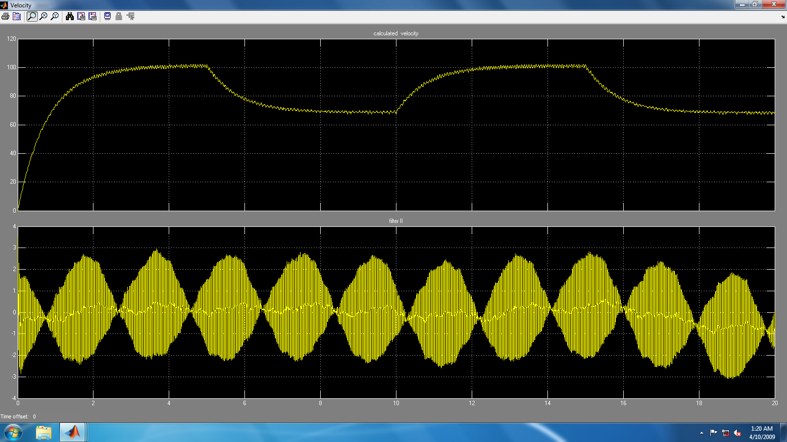

1. Let the first order system $G_{p}(s)$ be defined by $\frac{K_{0}}{τ_{0} s + 1}$. Determine $G_{p}(s)$ based on the data in Table 4.

Case 1: offset = $0V$

$$G_{p}​(s)=\frac{K_{0}}{τ_{0} s + 1} ​=\frac{100}{1.62s+1}​$$

Case 2: offset = $0.5V$

$$G_{p}​(s)=\frac{K_{0}}{τ_{0} s + 1} ​=\frac{180}{3.10s+1}​$$

1. Plot the responses of the linear model and the servo on the same pair of axes by applying a small step change from $V_{op} = 0.5V$ in your Simulink model.

So we chose 0.6V as our operational voltage and here is the result of the output:

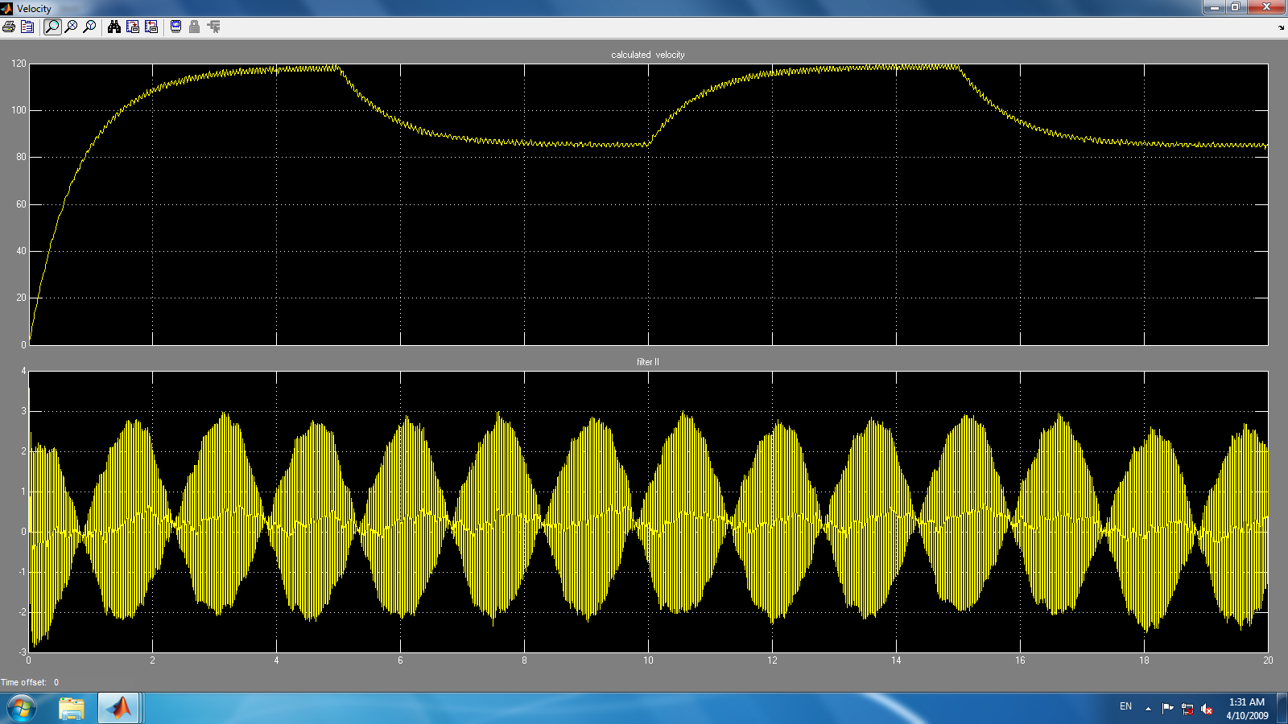

1. Compare the results. Does the response of the linear model reasonably fit the measured data? Explain the differences and check your derived model if necessary.

And in the second case as we can see in the images that are depicted down below, that our transfer function for 0.6V operation point was quite accurate. The first image is the ground truth signal and the second one is the curve-fitted transfer function’s result 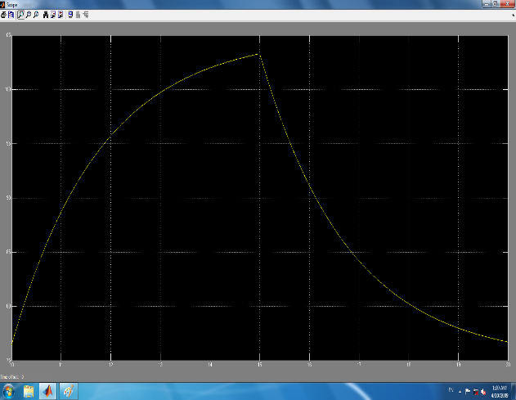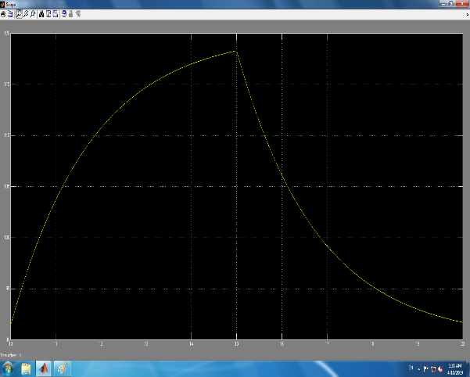

1. Determine the revised transfer function $Gp(s).$

Since our curve fitted model approximated the motor’s behavior quite with negligible error, we would not change the characteristics that we derived earlier:

Case 1: offset = $0V$

$$G_{p}​(s)=\frac{K_{0}}{τ_{0} s + 1} ​=\frac{100}{1.62s+1}​$$

Case 2: offset = $0.5V$

$$G_{p}​(s)=\frac{K_{0}}{τ_{0} s + 1} ​=\frac{180}{3.10s+1}$$

A first order system’s bode diagram has been plotted down below, we estimated that the time constant of the system was about $τ≈3$ seconds. So we chose the frequencies to be such that it contains $\frac{1}{τ}$.

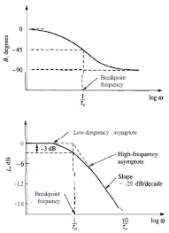

Since we got the phase of the output after 3 seconds that it was stable, we have to subtract the phase of the output in different frequencies at three seconds. Using this code, we got the phase of the input:

x = simout.signals.values;

T0 = 0.01;

t = 0:T0/5:10;

t_ss = t(t>=3);

x_ss = x(t>=3);

fs = 1/mean(diff(t));

l = length(x_ss);

x_fft = abs(fft(x_ss));

x_fft(1) = 0;

[~, idx] = max(x_fft(1:floor((l/2))));

f_est = (idx-1)*fs/l;

sine = @(b,t) b(1) * sin(2*pi*f_est* t + b(2));

error = @(b) sum((sine(b, t_ss(:))-x_ss(:)).^2);

b0 = [max(x_ss), 0];

b_opt = fminsearch(error, b0);

amp = abs(b_opt(1));

phase_rad = b_opt(2);

phase_deg = rad2deg(phase_rad);

fprintf('phase = %.4f\n', phase_deg);

fprintf('amp = %.4f\n', amp);

fprintf('amp db = %.4f\n', 20*log10(amp));

1. Record the excitation frequency, transfer function magnitude and transfer function phase lag measurement data in Table 5.

|  |  |  |  |  |
| --- | --- | --- | --- | --- |
| Frequency () |  | in $dB$ | Phase of output | $∠G\left(jω\right)$ in degrees |
| $$0.2$$ | $$75.13$$ | $$37.51$$ | $$-83.6$$ | $$60.40$$ |
| $$0.25$$ | $$73.14$$ | $$37.28$$ | $$49.61$$ | $$-40.39$$ |
| $$0.5$$ | $$32.27$$ | $$30.17$$ | $$-57.8$$ | $$57.80$$ |
| $$0.75$$ | $$30.46$$ | $$29.67$$ | $$8.09$$ | $$-80.11$$ |
| $$1$$ | $$25.82$$ | $$28.24$$ | $$-80.2$$ | $$-80.20$$ |
| $$1.25$$ | 18.64 | $$25.41$$ | $$14.58$$ | $$-21.42$$ |
| $$1.5$$ | $$11.24$$ | $$21.07$$ | $$-72.00$$ | $$-72.00$$ |
| $$1.75$$ | $$13.37$$ | $$22.52$$ | $$-2.50$$ | $$-87.50$$ |
| $$2$$ | $$12.99$$ | $$22.27$$ | $$-87.84$$ | $$-87.84$$ |
| $$2.25$$ | $$10.34$$ | $$20.29$$ | $$8.20$$ | $$-81.80$$ |
| $$2.5$$ | $$6.61$$ | $$16.41$$ | $$-76.71$$ | $$-76.71$$ |
| $$2.75$$ | $$8.45$$ | $$18.54$$ | $$-6.86$$ | $$-83.14$$ |

1. Plot and print the bode diagram of the system based on the experimental data.

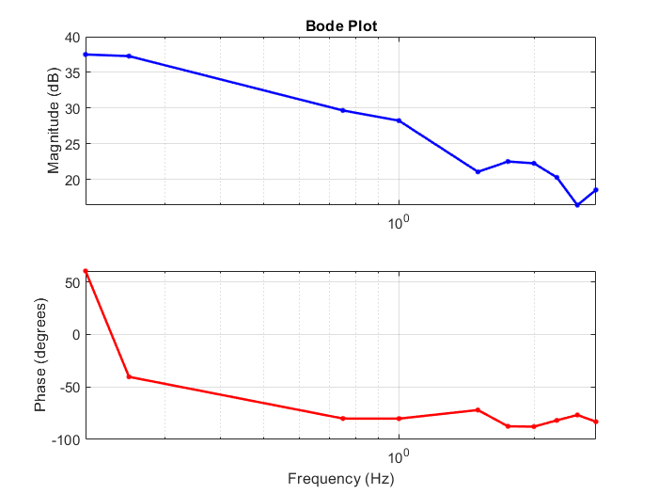

1. Record the system bandwidth, steady-state gain, gain margin and phase margin based on the obtained bode diagram.

**Bandwidth:** The bandwidth is the frequency range where the magnitude is within $-3 dB$ of the low-frequency (steady-state) gain. From the data, the low-frequency gain is approximately $37.51 dB$ at $0.2 Hz$. The $-3 dB$ point is $37.51 - 3 = 34.51 dB$. Interpolating roughly between $0.25 Hz$ and $0.75 Hz$, the -3 dB point is approximately $0.5 Hz$ (since the drop is significant by $0.75 Hz$). Thus, the bandwidth is approximately $[0, 0.5] Hz$.

**Steady-State Gain:** The steady-state gain corresponds to the magnitude at low frequencies. At the lowest frequency $(0.2 Hz),$ the magnitude is $37.51 dB$. Converting to linear gain: $G = {10}^{\left\{\frac{37.51}{20}\right\}}≈ 75.0$.Thus, the steady-state gain is approximately $75.0 (or 37.51 dB).$

**Gain Margin:** The gain margin is the amount by which the gain can increase before the system becomes unstable, found at the phase crossover frequency (where phase = $-180°$). The phase data does not reach $-180°$ within the given frequencies. Thus it is **infinite**.

**Phase Margin:** The phase margin is the difference between the phase and $-180°$ at the gain crossover frequency (where magnitude = $0 dB$). The magnitude data starts at $37.51 dB$ and decreases to $18.54 dB$ at $2.75 Hz$, if It goes with that slope, we can say it goes to $0dB$ at $13.3Hz$, thus it will be $90 degrees$ approximately.

1. What is the approximate rate of roll off (dB/decade) in the gain of the system?

To determine the approximate rate of roll-off (in $dB/decade$) in the gain of the system, we analyze the slope of the magnitude plot in the Bode diagram, focusing on the frequency range where the gain decreases significantly.

At $0.25 Hz$: $37.28 dB$

At $2.50 Hz:$ $16.41 dB$

Change in magnitude: $16.41-37.28=-20.87 dB$

Frequency ratio: $2.50.25=10$.

**Roll-off rate** = $-20.87dB/1decade ​≈-20.87dB/decade$

1. From the phase plot determine the frequency at which the system response lags the command signal by $45$ degrees? Plot and print the relationship between this frequency and the time constant of the system.

We need to find the frequency where the phase is $-45°$ (indicating a $45°$ lag, as negative phase denotes the output lagging the input). If we linearly interpolate between these two points, we will get:

At $0.25 Hz$, phase $= -40.39°.$

At $0.75 Hz$, phase $= -80.11°.$

Which results in $0.308 Hz$ having the phase $-45°$. For a **first-order system**, the transfer function is typically: $G\left(s\right)=\frac{K}{1+τs}$. Thus The phase of a first-order system is: $ϕ=-arctan\left(ωτ\right)=π/4$ which suggests:

$$ωτ=\tan\left(\frac{π}{4}\right)=1→τ=\frac{1}{ω}=\frac{1}{2πf}=0.5167$$

Now we can estimate the time constant which will be $τ=$ 0.51.

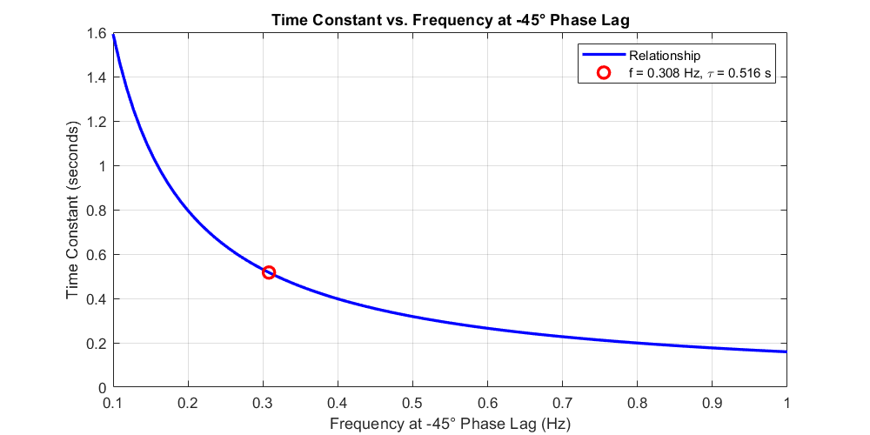

1. Determine the gain of the system for the command signals with very high frequencies. What would be the phase lag for such high frequencies?

At very high frequencies $ω→∞$, we will get: $|G\left(jω\right)|≈\frac{K}{τω}$ and the gain in $dB$ will be:

$20\log{K}-20\log{τω}$, and as $ω$ reaches infinity, $\left|G\left(jω\right)\right|≈0$ will converge to zero and its value in $dB$ will diverge to $-∞$.

Furthermore, the phase lag will converge to $-90°$:

$$ϕ=\lim_{ω→∞}{-arctan\left(ωτ\right)=}-\frac{π}{2}=-90°$$

1. Based on the obtained bode diagram, sketch the bode diagram of voltage-to position transfer function in Figure 1. Explain the position response of the servo motor to different sinusoidal excitation.
2. Determine the transfer function $G_{f}(s)$ from frequency response data.

Based on the bandwidth and Gain we calculated earlier we will get:

$$K={10}^{\frac{37.51}{20}}=75.07, f_{c}=\frac{1}{2πτ}=0.308Hz$$

Which will suggest: $$G_{f}\left(s\right)=\frac{K}{τs+1}=\frac{75.07}{1+0.51s}$$

The plot the is illustrated above shows that the curve fitted the data pretty well!

% Parameters from data

K = 10^(37.51/20); % Linear gain (~75.0)

tau = 0.516; % Time constant (s)

f_c = 1/(2*pi*tau); % Corner frequency (~0.309 Hz)

% Frequency range

f = logspace(-1, 1, 100); % 0.1 to 10 Hz

omega = 2*pi*f;

% Transfer function: G(s) = K/(tau*s + 1)

s = 1j*omega;

G = K ./ (tau*s + 1);

mag_dB = 20*log10(abs(G));

phase_deg = angle(G)*180/pi;

% Plot Bode diagram

figure;

% Magnitude

subplot(2,1,1);

semilogx(f, mag_dB, 'b-', 'LineWidth', 2);

hold on;

semilogx([0.2, 0.25, 0.75, 1, 1.5, 1.75, 2, 2.25, 2.5, 2.75], ...

[37.51, 37.28, 29.67, 28.24, 21.07, 22.52, 22.27, 20.29, 16.41, 18.54], ...

'ro', 'MarkerSize', 6); % Original data points

grid on;

ylabel('Magnitude (dB)');

title('Bode Plot: Voltage-to-Position Transfer Function');

xline(f_c, '--k', 'Corner Freq', 'LabelVerticalAlignment', 'bottom');

% Phase

subplot(2,1,2);

semilogx(f, phase_deg, 'b-', 'LineWidth', 2);

hold on;

semilogx([0.2, 0.25, 0.75, 1, 1.5, 1.75, 2, 2.25, 2.5, 2.75], ...

[60.40, -40.39, -80.11, -80.20, -72.00, -87.50, -87.84, -81.80, -76.71, -83.14], ...

'ro', 'MarkerSize', 6); % Original data points

grid on;

xlabel('Frequency (Hz)');

ylabel('Phase (degrees)');

xline(f_c, '--k', 'Corner Freq', 'LabelVerticalAlignment', 'bottom');

set(gcf, 'Position', [100, 100, 800, 600]);

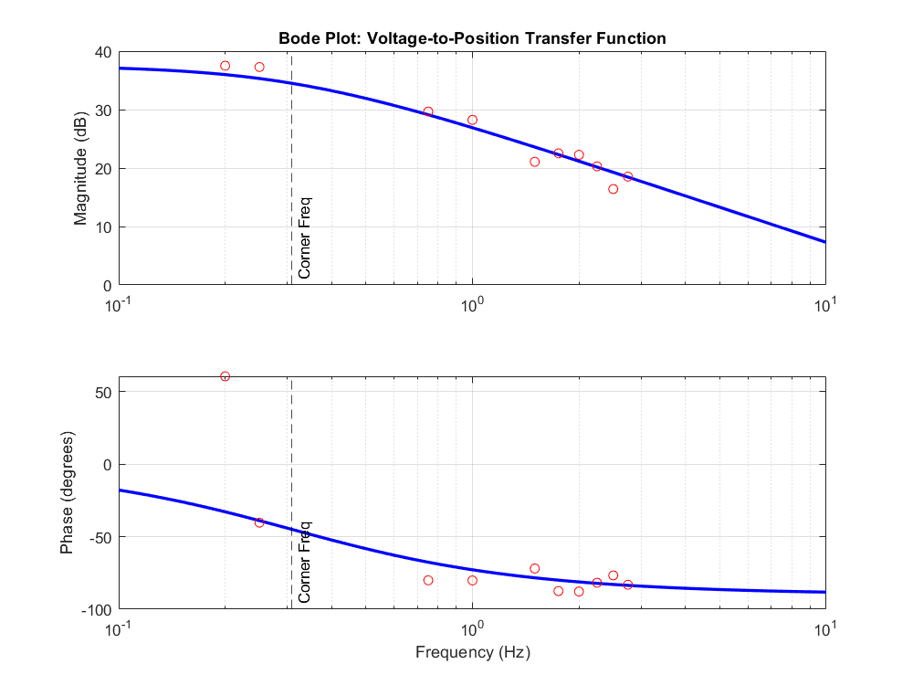

1. Plot and print on the same pair of axes, the bode plots of the experiment and the bode plots of the $G_{p}(s)$ and $G_{f}(s).$

As we recall from the earlier experiment in time domain identification we got:

Case 1: offset = $0V$

$$G_{p}​(s)=\frac{K_{0}}{τ_{0} s + 1} ​=\frac{100}{1.62s+1}​$$

Case 2: offset = $0.5V$

$$G_{p}​(s)=\frac{K_{0}}{τ_{0} s + 1} ​=\frac{180}{3.10s+1}$$

